TAX WORKSHOP

For Family child Care Providers
January 23, 2021
10:00 am to 12:30 pm

Register Here
www.caregistry.org
Held through ZOOM
Link will be emailed to you closer to the start date
Presenter is Fred Kenyon

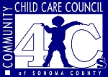
Would you like to have more deductions and a bigger tax return for your family child care business? Do you know which forms to use when filing your taxes with the IRS? This tax workshop will help you understand the requirements for filing your taxes with the IRS.
Presenter is Fred Kenyon from Kenyon & Associates

